June 30th, 2026
2PM UPDATE

ROAD AND STREET CLOSURES IN ASHERN
Highlighted in Green

1ST Ave North
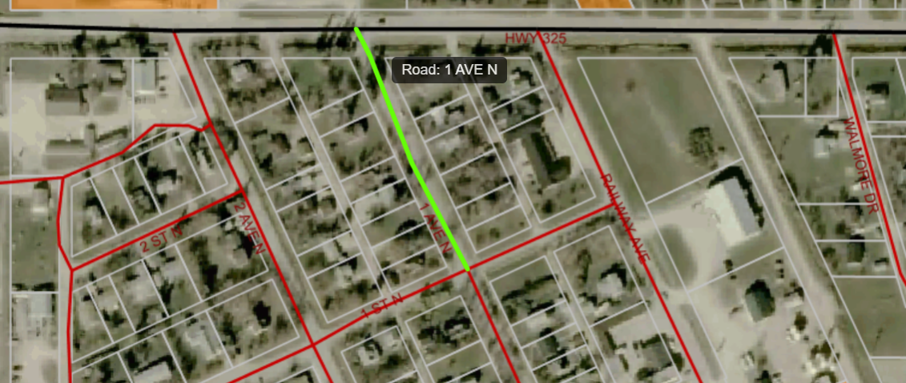

Railway Avenue
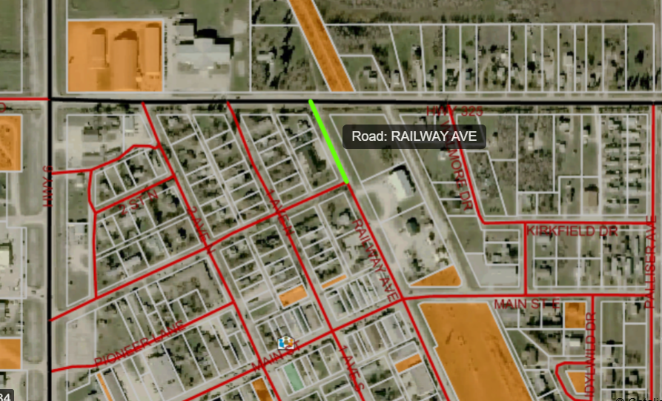

This section of Railway can still access Dodd’s Siding and Home Hardware however use caution as to not disrupt emergency personnel and equipment
