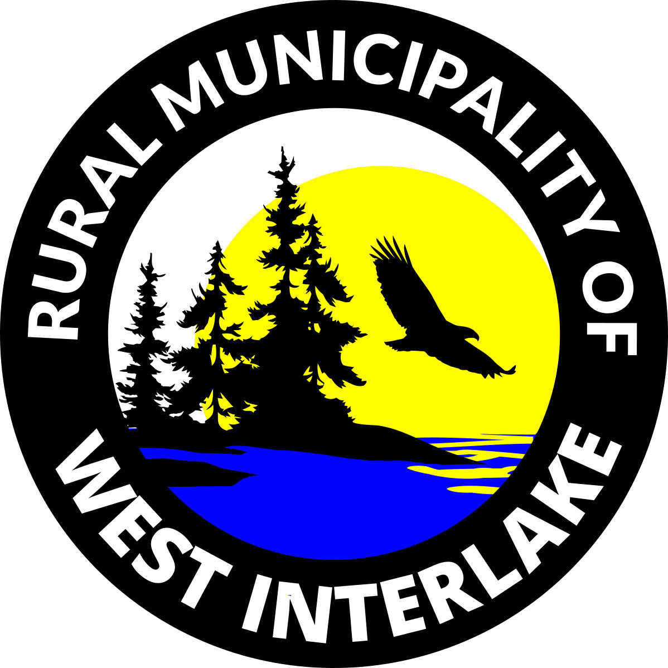
REQUEST for
SERVICE

Name:
Date:

Telephone: | Cell #: | Email:

Location of the requested service:
Ward Number:
Please indicate how you want to
be contacted for updates:
Type of Request: Select all that applies in relevance to your request

Culvert / Crossing
Grass Cutting
Beaver Dam Removal
Gravel
Signs
Grading works
Others; please specify:

Brief Summary of Request / Issues:

Waiver
I ___________________________, with my signature below, that all statements and concerns cited above are all true.

Signature: Date:

***********************************************************************************************************************************************************************************************************************************************************************
For RM Office Use ONLY
Received By:

Council’s Remarks:

Request Completion Target Date: Follow up Date:

Resolution #:

