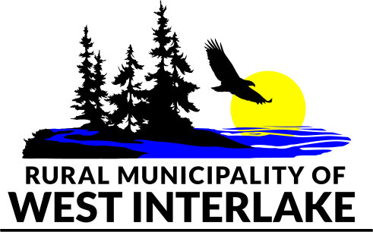 **Equipment Lending Agreement**

The R.M. of West Interlake (***the R.M.)*** requires that any individual wishing to rent any R.M. equipment (***the “Renter***”) must execute this Equipment Lending Agreement.

***The R.M.*** is lending to ***the Renter*** the following Equipment under this Equipment Lending Agreement (check all that apply) which are independently and collective defined as the “***Equipment”***

**Snow Shoes Walking Poles**

**The Renter acknowledges and agrees as follows:**

1. There is inherent risk pf personal injury to others in participating in physical activities involving the Equipment such as but not limited to, scrapes, abrasions, cuts, sprains, broken bones and torn muscles or ligaments. There is also some risk to personal property such as tears in outerwear. ***The Renter*** acknowledges these foreseeable and unforeseeable risks and assumes all such risks and liabilities that arise from the use of ***the R.M.’s*** Equipment.
2. ***The Renter*** hereby agrees to forever waive, release, indemnify, defend and hold harmless and the R.M. of West Interlake (R.M.), and collectively any of its agents, employees, contractors, licenses, sponsors, elected officials, volunteers, and any other persons for whom the R.M. may be responsible in law, from any and all claims whatsoever and howsoever arising, including but not limited to, claims for bodily injury and property damage, in connection with any damage, injury, illness or death which my directly or indirectly result from the Renter’s use of ***the*** ***R.M.’s*** Equipment.
3. If ***the Renter*** is executing this Agreement on behalf of a child or a minor that the Renter is responsible for as a legal guardian, the Renter hereby acknowledges and accepts the aforementioned risks and waiver in clause 2 on behalf of that child. No Renter shall be permitted to execute this Agreement on behalf a child or minor that ***the Renter*** is not responsible for as legal guardian.
4. ***The Renter*** is fully responsible for the Equipment borrowed and acknowledges that they are required to return the Equipment in person on or by the due date, and that Equipment shall not be returned using the drop boxes. Should the Equipment be damaged or lost, ***the Renter*** acknowledges that they are responsible for the full replacement cost. That cost is **$200.00** per pair of Snow Shoes.
5. Terms of use:

* Equipment rentals are on a first come, first serve basis.
* The Renter must be in good standing with the R.M.
* There are no renewals or holds.
* Overdue fines are $5.00/day per single pair of Snow Shoes
* Equipment must be signed out during working business hours.
* Equipment must be returned in good condition, clean and dry.
* If damaged, the Renter shall pay the full replacement cost of the Equipment.

Renter Name: _____________________________ Renter Phone #: ____________________________________

# of adult and sizes: ____________________________________________________ # of Child: ________ # of Poles: _________

I, as ***the Renter***, have read, understand, and agree to the terms of this Agreement for myself and any minor children in my care.

Signature: _______________________________ Date: _____________

R.M. employee signature: ________________________________ Date: _________________