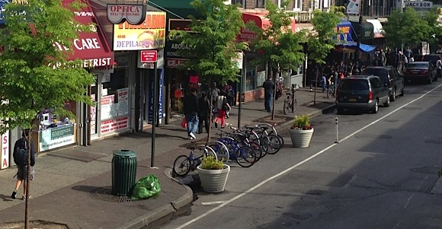

Ashern LUD

Streetscape Beautification Grant

**Questions & Answers**

**What is the Streetscape Beautification Grant?**

The LUD of Ashern has made the Streetscape Beautification Grant available to businesses in the qualifying area to assist successful applicants in beautifying their property. If you are a business owner who is a renter, you may still apply as long as the owner endorses your application. The Grant will provide 50% of the cost of the beautification project to a maximum grant amount of $1,000.00

**Is my business in the qualifying area?**

The grant applies to the following area:

* Commercial properties located in Ashern.

**What is the eligible criteria for the grant?**

* Is the property located in the eligible area?
* The applicant completed the funding application along with the signed memorandum of agreement
* Provides detailed concept plan of project
* Project improves overall appearance of building

**What costs are eligible?**

* Labour and materials to improve the exterior fascia of the business
* Other costs that have been identified and approved in advance and are considered to be direct and necessary to the success of the project.

**Am I eligible if I applied in prior year intakes?**

Yes, businesses who applied and were approved in 2020 will be eligible to apply again in 2021.

**Do all applicants that meet eligibility criteria get accepted?**

As funding is limited. All projects will be on a first come, first serve basis. Not all projects which meet the criteria will be approved. Do not assume the application is approved until notified in writing. Expenditures incurred before January 1, 2021 may be ineligible for reimbursement.

**What are the financial limits of the grant?**

The Streetscape Beautification Grant will support up to 50% of eligible project costs to a maximum of $1,000.00 per property. The grant is payable upon verification/inspection of project completion.

**What are the deadlines?**

Applicants have one year from the agreement date to complete the project

**How does the grant get approved?**

1. Applications are reviewed by the Ashern LUD Committee for eligibility and completeness.
2. Supporting documents must accompany the application.
3. Award decisions are made by resolution of the Ashern LUD and communicated to applicants.
4. Payment will be reimbursed upon project completion.

**How to apply?**

Submit a completed Application, along   
with required supporting documentation to:

**Jodi Thorkelsson**

RM of West Interlake

Ashern LUD

Box 370

Ashern, MB R0C 0E0

[info@rmofwestinterlake.com](mailto:info@rmofwestinterlake.com)

**Funding Application Form**

|  |  |
| --- | --- |
| DATE: | Click or tap here to enter text. |
| BUSINESS NAME: | Click or tap here to enter text. |
| BUSINESS TELEPHONE: | Click or tap here to enter text. |
| BUSINESS FAX NUMBER: | Click or tap here to enter text. |
| BUSINESS MAILING ADDRESS: | Click or tap here to enter text. |
| BUSINESS STREET ADDRESS:  (if different from mailing address) | Click or tap here to enter text. |
| DETAILS OF CONTACT PERSON:  (Name, cell phone number, email) | Click or tap here to enter text. |
| PROJECT NAME: | Click or tap here to enter text. |
| ESTIMATED TOTAL COST OF PROJECT: | Click or tap here to enter text. |
| ESTIMATED DATE PROJECT TO COMMENCE: | Click or tap here to enter text. |
| ESTIMATED DATE PROJECT TO BE COMPLETED: | Click or tap here to enter text. |

Are you the property owner? Yes No

I have read and agree to the terms & conditions of the attached agreement.

________________________ _______________________

Signature of Property Owner Signature of Applicant

(if applicable)

Date:Click or tap here to enter text. Click or tap here to enter text. Applicants name clearly printed

OFFICE USE ONLY

Application Approval Date:      Resolution:

LUD Chair Signature: _______________________

LUD Administrator Signature: _________________

**MEMORANDUM OF AGREEMENT**

Made this _______ day of __________ A.D.2021, between:

______________________________________

(hereinafter referred to as the “Applicant”)

AND

Local Urban District of Ashern

PO Box 370

Ashern, MB R0C 0E0

**WHEREAS** the LUD of Ashern is prepared to contribute funds for the beautification of public and private lands within the Town of Ashern, up to 50% of costs to a maximum of $1,000.00 for property beautification;

**AND WHEREAS** the above-mentioned party was approved by the LUD of Ashern to qualify for such funding;

**NOW THEREFORE** the above parties agree to the following:

1. All work being claimed for funding has been completed with proof of invoice that itemizes the beautification costs.
2. The Applicant shall assume all maintenance costs for the improvements.
3. Parties may qualify for grant funding up to a maximum of $1,000.00.
4. The subject beautification project shall be completed within one year of the date of this agreement.

IN WITNESS whereof the parties hereto have affixed their signatures below on this ____ day of ____________ A.D. __________.

______________________ _______________________

Witness Applicant Signature

______________________ _______________________

Witness LUD of Ashern