WESTERN INTERLAKE PLANNING DISTRICT
Box 269, St Laurent, MB, R0C2S0
UNDER THE AUTHORITY OF THE PLANNING ACT NOTICE
OF PUBLIC HEARING
On the date and at the time and location shown below, a PUBLIC HEARING will be held to receive representations from any persons who wish to make them in respect to the following matter:
APPLICATION FOR CONDITIONAL USE UNDER THE RM OR ERIKSDALE ZONING BYLAW 7/05.
HEARING LOCATION: RM OF WEST INTERLAKE COUNCIL CHAMBERS
38 MAIN ST, ASHERN, MB

DATE & TIME: OCT 6th, 2026, at 10:15AM
APPLICATION: CUWI-03-26
OWNERS/APPLICANT: Marnie Holm-Mills & Llyod Holm
GENERAL INTENT: Cannabis Retail Store
AREA AFFECTED: 26 Railway Ave. /Lot 1, Block 2, Plan 408 in the RM of Eriksdale
FOR INFORMATION
CONTACT: Cherie Millar, Office Administrator, Western Interlake phone: 204-646-2615, fax: 204-646-4150, email: westerninterlakeplanning@gmail.com

A copy of the above proposal and supporting material may be inspected at the location noted above during normal office hours, Monday to Friday. Copies may be made and extracts taken there from the upon request.
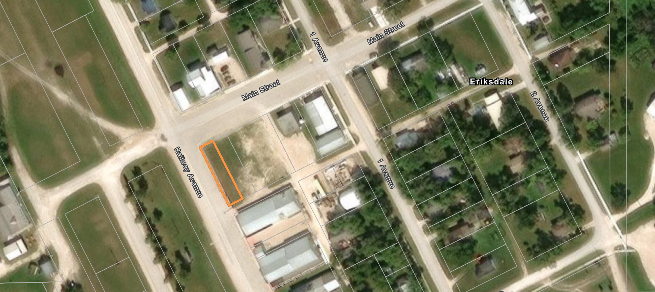

1 Avenue
Main St.
Railway Ave
