WESTERN INTERLAKE PLANNING DISTRICT
Box 269, St. Laurent, Mb R0C 2S0

UNDER THE AUTHORITY OF THE PLANNING ACT
NOTICE
OF PUBLIC HEARING

On the date and at the time and location shown below, a PUBLIC HEARING will be held to receive representations from any persons who wish to make them in respect to the following matter:

APPLICATION FOR VARIATION ORDER under the RM OF SIGLUNES ZONING BY-LAW NO 6/05

HEARING: The Ashern Centennial Hall, Rd #325 and Hwy #6 North, Ashern, Mb.

DATE & TIME: November 24th, 2025 @ 2:00 pm

APPLICATION: VWI-03-24

OWNERS/ RURAL MUNICIPALITY OF WEST INTERLAKE
APPLICANT:

PROPOSAL: RM of Siglunes Zoning Bylaw 6/05 Section 3.24 and Section 3.9 c)
To vary the off-street parking and loading spaces AND to vary the separation distance between a main building and an accessory building

FROM: required 4 off-street parking spaces and 1 off-street loading space AND 10 ft separation distance between a main building and an accessory building

TO: 0 off-street parking spaces and 0 off-street loading spaces AND 3 ft separation distance between a main building and an accessory building

To allow the construction of an addition to a Government Office to comply with the zoning bylaw

ZONING: Commercial General

AREA #1 2nd Ave S, Lot 10, Block 3, Plan 18672, Ashern, Manitoba in the RM of West
AFFECTED: Interlake, (outlined in a solid orange line)

FOR INFORMATION Cherie Millar, Office Administrator, Western Interlake Planning
CONTACT: District, phone 204-646-2615, email wipd@mymts.net

A copy of the above proposal and supporting material may be inspected at the location noted above during normal office hours, Monday to Friday. Copies may be made and extracts taken therefrom, upon request.

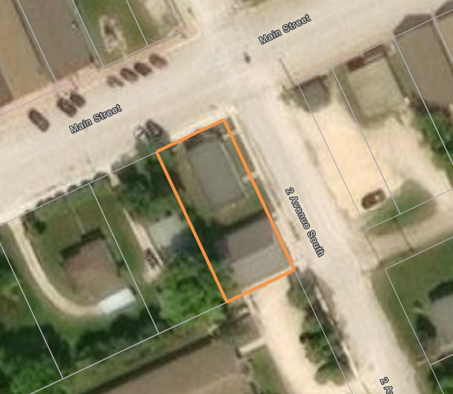
ASHERN

Why did I receive this notice?
An application has been made to Council regarding the use of a property in your neighbourhood. As required under the Planning Act, this notice of public hearing has been sent to all property owners located within 100 meters (328 feet) of the affected property.

Do I have to attend the Public Hearing?
Anyone is welcome to attend the public hearing and to make representations for or against the application, however you are not required to attend.

What if I want to express my opinion, but can’t attend the Hearing?
If you are unable to attend but wish to make representation, you may file a written submission in-person at the municipal office or Planning District office, by email, or by regular mail prior to the public hearing. All submissions will be available for public inspection at the Planning District office immediately upon receipt, and will be presented at the hearing. Anonymous submissions or phone calls will not be accepted or addressed at the hearing. Attendance by communication facility (telephone) is also an option.

What happens at the Public Hearing?
Council hears the conditional use or variance application in public at the date and time listed on the notice. The purpose of the public hearing is for Council to receive representations. Council may ask the applicant questions about the proposal and then provides the opportunity for anyone to either speak for or against the application, and any written submissions or reports are presented to Council. When all representations are completed, the public hearing will close. Council's decision may be made at the meeting immediately following the hearing, or may be deferred to a later meeting. When Council makes its decision all persons who made a representation at the hearing will be notified. When the hearing is concluded, there are no further chances for anyone to speak to Council regarding the application.

What is zoning?
The Planning Act requires that every municipal council must adopt a zoning by-law. A zoning by-law enables council to adopt specific regulations for the use and development of land. The zoning by-law must divide the municipality into zones, and prescribe the permitted and conditional uses of land and buildings in each zone and the general development standards applicable in each zone. The zones should reflect the future pattern of land uses set out in the development plan and should also consider existing land uses.

What does a Conditional Use mean?
An essential feature of each zone is the list of permitted uses and conditional uses. A "permitted use" is a use of land or buildings that will be allowed provided the proposed development meets the requirements set out in the zoning by-law. A "conditional use" is a use of land or buildings which may or may not be acceptable in a zone depending on the circumstances of the proposed development. Council may consider it appropriate to impose conditions on the development in order to ensure that it will be compatible with the general nature of the surrounding area, will not be detrimental to the health or general welfare of people living or working in the surrounding area, or negatively affect other properties or potential development in the surrounding area, will be acceptable at the proposed location in the zone, and will not create a land use conflict. For example, certain local commercial uses may be listed as conditional uses in a residential zone. While the uses may be generally acceptable in the zone, council may impose conditions such as parking, access signage or hours of operation to ensure that the proposed use is appropriate for the zone. As the conditional use can affect neighboring properties, there is a requirement for public notice of the application and a public hearing to receive representations on the proposed use.

What is a Variance?
A zoning by-law is a by-law of general application to the entire municipality. As a general by-law it may not be able to adequately deal with the unusual or unique conditions of specific properties. Strict application of the by-law could result in hardship in some instances. The variance process allows council to vary the application of the zoning by-law as it affects the person's property. An example of a person who is adversely affected by a zoning by-law would be someone whose parcel of land is oddly shaped, unusually small or has physical characteristics that make complying with the requirements of a zoning by-law impractical or unreasonable. That person would be entitled to seek a variance that would relieve them from complying with the provisions of the zoning by-law that adversely affect this use of the land. Since a variance alters the application of the zoning by-law as it affects a specific property it can also affect neighboring
properties. There is, therefore, a requirement for public notice of the application and a public hearing to receive representations on the proposed variance.

